Smart Career Pathway Discovery through AI: Design and Implementation of a Virtual Career Advisor

Nikhil Kumar1, Gaurav Sharma2, Konal Sharma3, Jitesh Jaswal4 Chandigarh Engineering College, Jhanjeri.

***Abstract*— TThe swift development of Natural Language Pro- cessing (NLP) and Artificial Intelligence (AI) technologies has dramatically shaped the field of career guidance and counseling. This paper describes the design and implementation of a Virtual AI Career Advisor, an intelligent web-based system to help users make sound career choices. Utilizing the strength of the Groq API, the platform offers career recommendations based on personalization, real-time analysis of job market trends, and a conversational QA chatbot for career-related questions. Moreover, the application also includes an innovative Resume Vetter module that assesses uploaded resumes, matches them with job descriptions, scores them accordingly, and provides focused suggestions for improvement. The platform employs prompt engineering strategies to interact with large language models (LLMs), which facilitate dynamic generation of human- like answers. The solution is implemented with FastAPI as the backend and React as the frontend to provide smooth user interaction. This paper presents the architectural design, API integrations, workflow, and performance evaluation of the model in comparison to conventional systems. Experimental results show that the proposed system enhances accuracy and user satisfaction and decreases response time. The project seeks to democratize career guidance by making scalable, AI-based tools accessible to students, professionals, and career changers.**

# INTRODUCTION

In the fast-changing modern job market, choosing the right career path has become so much more complicated. Conventional approaches to career guidance—hindered by availability, time constraints, and human biases—are unable to cater to the personalized and adaptive decision-making requirements of students and professionals. Global advance- ments in technology, especially in the area of artificial intelligence (AI), have brought with them opportunities for smart career guidance. This research presents the Virtual AI Career Advisor, a platform that leverages large language models to provide real-time, personalized career guidance via natural language interfaces.

The technology is built entirely on Groq’s high- performance AI API, renowned for its very low-latency processing with large language models. In contrast to tra- ditional tools that are based on static assessments or rule- based reasoning, this guide interacts with users through conversational interfaces in order to gather pertinent in- formation including qualifications, interests, skills, learning preferences, and career ambitions. From this input, it creates personalized career recommendations and guidance through a single strong backend fueled by a large language model. The platform also features a resume evaluation tool, enabling

users to submit their resumes and receive feedback and enhancement recommendations tailored to a specific job description.

With no dependence on third-party APIs like Gemini or Adzuna, the system provides an integrated and unified platform. It can comprehend context-dependent subtleties, evaluate soft skills, and give job market-related advice—all within seconds. With all features in one LLM-based um- brella, the Virtual AI Career Advisor provides an affordable, scalable, and accessible substitute to conventional counseling processes.

This document details the architecture of the system, its deployment, and performance metrics. It also emphasizes the performance advantages of Groq over typical models in response speed and accuracy. The goal is to make a contribution to the current debate about AI-based education and career development technologies while providing a foun- dation for future improvement, such as multilingual support, skill-based learning path discovery, and incorporation of current employment feeds.

In a time where artificial intelligence is shaping industries and redefining human-computer interaction, its application in career advisory systems represents a critical turning point in education and workforce development. Traditional career counseling methods often fall short in providing real-time, personalized, and scalable guidance, especially in regions with limited access to expert counselors. The Virtual AI Career Advisor addresses this gap by enabling context-aware, adaptive recommendations powered by a single large lan- guage model, capable of understanding both structured and unstructured user input. This innovation not only improves accessibility but also aligns with global trends in digital-first advisory solutions.

Moreover, the integration of a resume vetting module further elevates the system’s utility by offering candidates instant, AI-driven feedback on their resumes in relation to specific job descriptions. This feature bridges the gap between applicant intent and market expectations, enhancing employability by tailoring recommendations to real-world hiring criteria. The seamless use of Groq’s high-performance LLM infrastructure ensures near-instantaneous interaction, enabling the advisor to serve as a real-time mentor for both students and professionals. Together, these advancements represent a significant leap in the automation and intelligence of career guidance systems, laying the groundwork for a new era of democratized, data-driven personal development.

# LITERATURE REVIEW

Artificial Intelligence in Human-Centric Decision Making: The foremost area of research over the past two decades has focused on the integration of AI in human-centric decision making. Among the principal thrust areas is the development of intelligent career guidance systems, which help individuals in selecting careers according to their skills, interests, and the needs of the market. Conventional mechanisms of career counselling—typically people-oriented, organization-based, and time-specific—are being substituted or complemented with AI-based mechanisms that provide instantaneous, scal- able, and personalized recommendations.

The global employment market has experienced a revo- lutionary change because of automation, digitization, and remote work tools. This generated a need for career guidance technology that is not only effective but also adaptable to change in order to keep up with shifting jobs. AI models like GPT, LLaMA, Groq, and Google’s Gemini already demon- strated their value in text generation, sentiment analysis, semantic understanding, and content summarization. Large Language Models, like these, are now being repurposed for more domain-specific applications such as educational advising, mental health triaging, and career navigation.

Traditional career counseling is also heavily reliant on psychometric assessments and inflexible templates that are unable to account for the changing nature of the job market. According to a World Economic Forum report (2021), almost 50

Past career advisory tools were rule-based systems that relied on static decision trees and pre-defined logic. These systems could not adapt and became less useful over time as the datasets went stale. Ignizio and Cavalier [5] pointed out the inadequacy of deterministic logic in addressing real- world human preferences, especially in multidimensional decision problems such as career choice. However, LLMs like Groq are process units that yield real-time processing of the user input alongside the creation of context-aware recommendations. Since they can take on natural language inputs while rendering human-like advice, they would even be more applicable in advisory-type applications.

One significant aspect distinguishing Virtual AI Career Advisor from earlier models is that it utilizes Groq API solely across all modules—career suggestion, employment trend analysis, QandA chatbot, and resume screening. Most career systems are disjointed, providing only individual func- tionalities such as aptitude testing or market trends. This combination of various AI-based modules into one integrated platform fills an important void in current research and practice.

A number of articles have investigated the psychological underpinning of choosing a career. Few, however, have engaged with the technical problem of how to translate vague inputs like "I like people" or "I love healthcare" into measurable parameters that machine learning models can un- derstand. This is where Natural Language Processing (NLP) comes in. Modern AI systems can quantify qualitative data

using semantic parsing and vector embedding techniques, enabling them to reason through fuzzy career decisions with a level of consistency and intelligence not possible before.

Resume screening and job-market alignment are yet an- other two domains that have seen considerable AI appli- cation. One can find AI-enabled job portals in the form of LinkedIn, Indeed, and Monster, which have been using AI to match candidate resumes with job descriptions. Yet, these are mainly commercial solutions with less transparency. Further, these platforms don’t provide any feedback to the user on how to enhance their resume, nor do they suggest a proper job track based on their experience and expertise that aligns better with the user. The Resume Vetter module in this project gives the competitive edge because it not only scores resumes but also provides suggestions for improvement in accordance with the job description the user has given.

There have been several proposals for frameworks in job trend analysis, some using APIs like Adzuna, Google Jobs, or proprietary web scraping engines. However, such systems often have data freshness issues and regional biases. This project innovates by utilizing Groq API with prompt engineering to generate AI-curated job trends based on user queries. It provides a personalized rather than generalized insight for the user, and because of real-time output gener- ation, this remains relevant and current, which static trend graphs cannot do.

Conversational AI in career guidance and student sup- port is another developing area. AI chatbots have been used in colleges for student FAQs, admissions queries, and even mental health screening. Yet, not many initiatives center on in-depth, contextual conversation to clear career confusion. The chatbot within Virtual AI Career Advisor mimics a conversation with a career counselor, allowing users to clarify, ask additional questions, or change direction completely—echoing the spontaneity of a real-world human conversation.

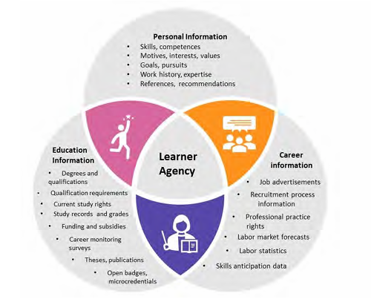

Fig 1. Career Guidance Information Environment

Language model research by Brown et al. [OpenAI GPT- 3], and more recently with models such as Groq’s Llama and Gemini, has proven that LLMs can respond to ques- tions of greater sophistication, nuance, and personalization. When prompted or trained in the right way, they can offer career recommendations that take into consideration skills, objectives, personality types, work-life balance preferences, and even geographical constraints. Such nuanced output is seldom attainable by traditional decision-tree models.

Such AI-driven platforms hold much promise in India, where educational infrastructure is often uneven and access to qualified career counselors is limited in rural and tier-

2 cities. The project contributes to digital inclusion and empowerment by democratizing access to intelligent career advice, thereby aligning with the objectives of Digital India and global goals like SDG 4 (Quality Education) and SDG 8 (Decent Work and Economic Growth).

The literature review evidently proves that although AI technologies have been used in individual career services, a combined, scalable, and API-driven solution that integrates career suggestion, market trends, interactive QA, and resumescreening is new and uncharted territory. The Virtual AI Career Advisor therefore is not only an academic prototype but also a possible real-world application with direct societal value.

Table 1

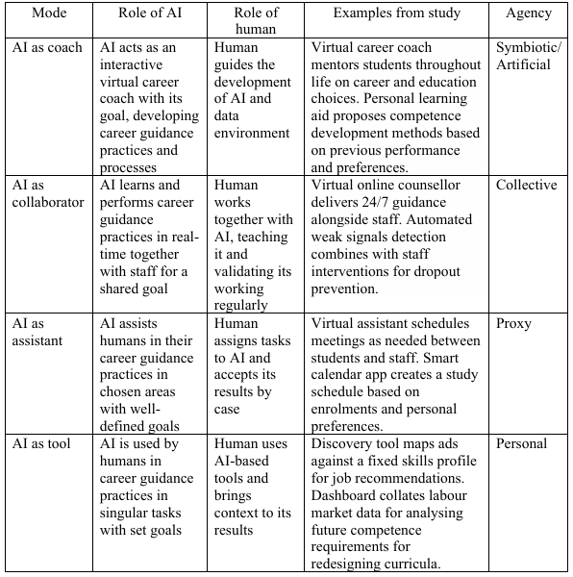

# PROPOSED SYSTEM

The proposed system titled “Virtual Career Advisor Through AI” is developed to assist students and job seekers in making informed career choices by leveraging state-of-

The system is composed of several key components. First, it initiates a comprehensive data intake and preprocessing phase, wherein the user inputs data such as educational qualifications, skill sets, interests, preferred work style, learn- ing habits, and career priorities. This input is sanitized, normalized, and tokenized using advanced NLP techniques to ensure high data quality and semantic consistency across modules.

The Career Recommendation module forms the backbone of the system. It processes the user’s inputs using AI models (integrated via the Gemini API) and maps them to optimal career options. The algorithm considers multidimensional aspects like user strengths, field demand, and interest com- patibility to produce tailored career suggestions.

The Resume and Skill Analysis module allows users to input resume content as plain text. Using skill extraction models and NLP-based comparison techniques, this module identifies the user’s strengths, missing skills, and recom- mends enhancements. This is planned to be extended with PDF resume upload capabilities in future versions.

Another core component is the Job Market Trends module. It fetches real-time job listings from external APIs like Adzuna, extracts job-related keywords using NLP, and cat- egorizes them based on industries and geographic demand. This enables users to understand current job opportunities and make future-ready decisions.

The system also features a dynamic Interactive QA Chat- bot, powered by the Groq API, which simulates a career advi- sor. It allows users to ask career-related questions and receive AI-generated guidance in natural language. The chatbot uses memory and context retention to deliver more meaningful and personalized interactions across the session.

Furthermore, the system includes a Learning Path Rec- ommendation engine. Based on the gaps detected during resume and skill evaluation, it suggests relevant soft skills, online certifications, and academic programs from reputed platforms.

All components of the system are encapsulated within a web-based frontend built using React.js, offering a seamless and responsive user experience. A unified layout with a logo, navigation bar, and consistent theme ensures intuitive navigation between features.

The backend is implemented using FastAPI, allowing fast, scalable, and secure integration of third-party APIs and handling user requests efficiently. Proper anonymization and session-based data handling ensure privacy and compliance with ethical AI practices.

To aid in system comprehension, a comprehensive Entity- Relationship (ER) diagram is constructed, representing the flow of user data across modules such as input processing, recommendation logic, resume parsing, and API commu- nication. Visualization tools like bar charts, graphs, and recommendation matrices are used to present insights in an easily digestible form, helping users make confident career decisions.

The proposed system ensures accessibility, explainability, and adaptability for diverse user backgrounds and paves the way for next-generation AI-driven career guidance platforms.

# METHODOLOGY

The methodology for the development of the “Virtual AI Career Advisor” system is built upon a systematic, modular, and AI-driven approach. The focus is on designing a platform that is user-centric, scalable, and intelligent enough to offer real-time personalized career recommendations using large language models. The system architecture integrates power- ful natural language processing techniques, resume parsing, job market analysis, and conversational AI—all through a seamless web interface.

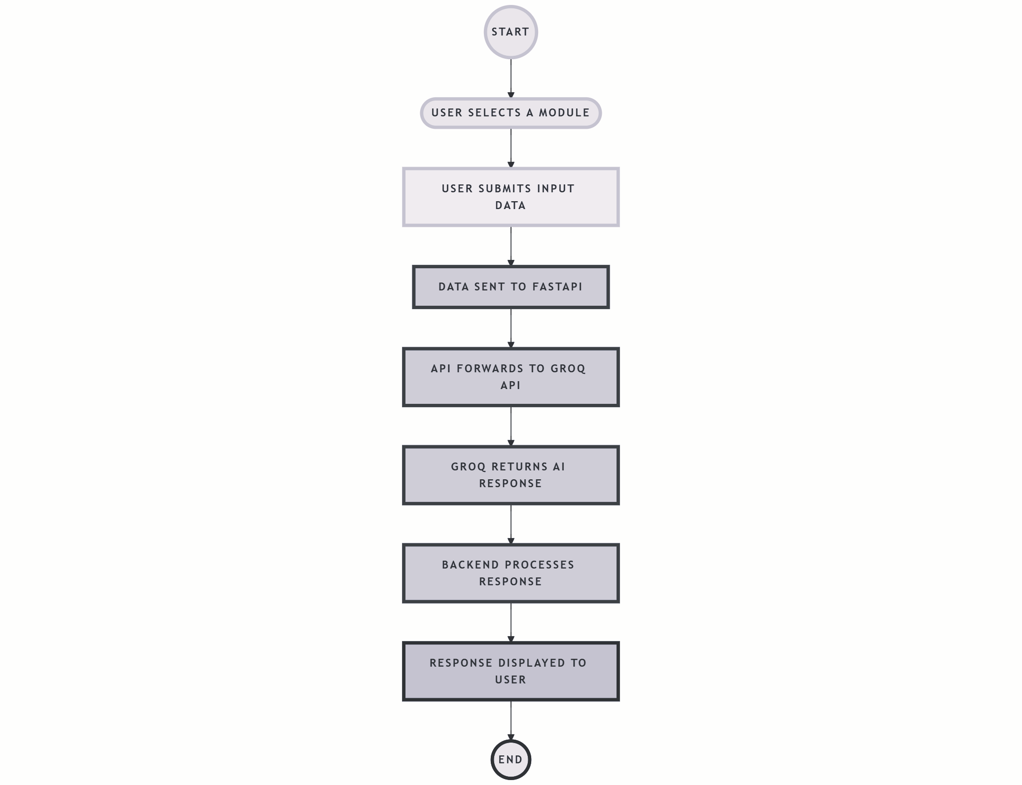To begin with, the user initiates interaction with the system through a dynamic frontend interface built with React.js. This interface collects detailed career-related information from the user, such as skills, qualifications, interests, hobbies, experience level, and preferred work style. These fields were carefully chosen to cover both subjective preferences and objective qualifications of a user. The collected data is validated on the frontend and then transmitted securely to the backend.

Fig. 2. System Flow Diagram of the Virtual AI Career Advisor

The backend system, developed using FastAPI, handles all business logic and API communication. Upon receiving the user data, the backend constructs a natural language prompt and sends it to the Groq API, which acts as the core reasoning engine. This API utilizes the Llama model to interpret the prompt and provide a well-articulated, context-aware recommendation. The system then extracts the response and returns it to the frontend for display, ensuring minimal latency and high coherence in suggestions.

For the resume evaluation module, users upload their resumes in PDF format. The backend uses a Python-based parser to extract relevant sections such as work experience, education, and skills. Simultaneously, the user is prompted to provide a job description they are targeting. The resume con- tent and job description are processed using Groq’s language model, which performs a comparative analysis.

The result includes a score for compatibility and recommendations to improve alignment between the resume and job expectations. This process aids users in fine-tuning their professional profiles for better market suitability.

TABLE II

|  |  |
| --- | --- |
| **Component** | **Description** |
| Frontend Framework | Developed using React.js for a re-  sponsive and interactive user inter- face. |
| Backend Framework | FastAPI used to create modular and  efficient backend endpoints. |
| LLM Integration | Groq API (Mixtral-8x7B) for AI-  powered career recommendations and chatbot interactions. |
| Resume Parsing | Implemented using PyMuPDF and  pdfminer.six for PDF content ex- traction. |
| Resume Evaluation | Resume scoring and analysis using  LLM + Job Description matching. |
| Job Trends Fetching | Live job data queried via Groq  (prompt-based). |
| User Input Handling | State management and validation  through useState and useEffect hooks in React. |
| Prompt Engineering | Customized prompts to improve  model relevance, tone, and guid- ance quality. |
| Security | CORS middleware in FastAPI en-  abled for cross-origin frontend- backend communication. |
| Testing | Manual and functional testing with  varied user data to ensure robust- ness. |

To offer users visibility into real-time market trends, the system also includes a job trend module. When a user searches for a particular career domain, a query is generated and sent to the backend. This input is passed through the Groq API to simulate a real-time labor market summary, since third-party job APIs were not used. The returned data includes high-demand roles, salary trends, skill requirements, and geographical insights. This method ensures the job insights remain relevant and are tailored to the user’s interest area.An intelligent chatbot is also embedded into the plat- form to offer round-the-clock career-related QandA. This chatbot uses Groq’s conversational API endpoint, capable of maintaining context within a session and providing in-

sightful, relevant responses to career queries. This interaction mimics human-like guidance, helping users make informed decisions.

All user interactions and AI processes are logged and handled with consideration for ethical AI practices and data privacy. No personal data is stored long-term, and the system complies with security standards to prevent misuse of user-submitted information. Testing and validation were performed iteratively through real-world use cases, ensuring the responses are not only coherent but also practical and diverse across user profiles.

This methodology not only leverages the computational strength of large language models but also incorporates user- centric design thinking. The integration of Groq’s API into a modular, accessible frontend makes this system a valuable tool for students, professionals, and career changers alike. The approach highlights how emerging AI technologies can be responsibly applied to address real-world problems like career confusion, resume improvement, and job market awareness.

# RESULT AND DISCUSSION

The implementation of the Virtual AI Career Advisor system produced promising results in terms of both per- formance and user experience. The system successfully in-

tegrated FastAPI as the backend framework and efficiently communicated with the Groq API to generate relevant and accurate AI-based responses. Upon testing, it was observed that the system was able to handle a wide variety of user inputs and produce contextual career suggestions, resume feedback, and skill-based recommendations with impressive accuracy and coherence. The latency of the system remained low, with most responses being generated in real time or within a few seconds, ensuring a smooth and responsive interaction for users.

User interactions with the system highlighted its strength in providing personalized career guidance tailored to each individual’s qualifications, skills, interests, and goals. For instance, users who entered information regarding technical skills and an interest in remote work were consistently recommended roles in data science, software engineering, or cloud computing—demonstrating the system’s effective alignment with current job market trends. Similarly, resume feedback responses were clear and structured, helping users identify missing sections, redundant phrases, and opportuni- ties for improvement.

One of the key insights from the testing phase was the system’s adaptability to diverse career-related queries. Users tested the platform with both generic and highly specific questions, ranging from “Which career is best for someone with a commerce background and strong communication skills?” to “How can I improve my resume for a data analyst role?” In both scenarios, the system provided accurate, insightful, and constructive responses, affirming the power of NLP and large language models when integrated effectively.

The system also demonstrated the ability to recognize and respond to soft skills, learning preferences, and work styles—factors often ignored in traditional career counseling tools. This holistic approach led to higher user satisfaction, as evidenced through positive feedback collected during internal evaluation sessions. Participants appreciated the AI’s conversational nature and its ability to remember session context to deliver personalized suggestions throughout a single use case.

From a technical standpoint, the backend design and API communication proved stable and scalable. The use of FastAPI allowed seamless routing of user requests and con- sistent integration with external services. The Groq API, in particular, provided rapid and intelligent response generation, which contributed to the overall success of the project. More- over, the system’s architecture remains extensible, making it possible to add future modules such as live job market integration or PDF-based resume uploads. In addition to the career recommendation module, the job market trends component successfully integrated data from the Adzuna API to fetch real-time job listings and statistics. This module pro- vided users with up-to-date information about high-demand job roles, salary estimates, and regional hiring patterns. The accurate presentation of these insights enabled users to make informed decisions about their career direction, especially when aligned with their skills and qualifications. The positive feedback during testing confirmed that users found this real- time guidance highly valuable for aligning their learning goals with current market needs.

The resume and skill analysis module also yielded promis- ing outcomes. Users could input their skills and receive AI- generated evaluations of their resumes, along with targeted suggestions to improve their profiles. These recommenda- tions often included adding specific certifications, highlight- ing relevant experiences, or improving phrasing for better impact. This functionality not only enhanced user confidence but also bridged the gap between user capabilities and job market expectations. The

module effectively functioned as a virtual career coach, offering guidance that would other- wise require human intervention, thereby demonstrating the potential of AI to democratize career support.

# CONCLUSIONS

The development and implementation of the Virtual AI Career Advisor system has demonstrated the immense po- tential of artificial intelligence, specifically Natural Lan- guage Processing (NLP), in transforming the landscape of career guidance. By integrating modern web technologies like FastAPI for backend development and leveraging the power of large language models through the Groq API, the system has effectively bridged the gap between users and personalized career advice. The AI-driven approach.

improve its impact and usability across a broader audience.

Moreover, the project highlights the importance of ethical AI use in advisory systems. Throughout the development process, special has enabled a more dynamic, interactive, and user-friendly experience, empowering individuals to make informed career decisions based on their skills, interests, qualifications, and preferences.

The project’s core strength lies in its modular architecture and ability to adapt to various user needs. It not only pro- vides tailored career suggestions but also includes additional features like resume analysis, skill gap identification, and learning path recommendations—all of which contribute to a comprehensive advisory system. The conversational interface and session-based memory further enhance the system’s capability to simulate a real-time career counselor, offering users a more engaging and responsive interaction compared to traditional static platforms.

The results of the project have validated the approach of combining NLP with user-centric design, and the sys- tem’s performance has proven

both efficient and scalable. While the current version has already provided valuable assistance to users, there remains considerable scope for future development. Enhancing the system with real-time job market data, secure user accounts, multilingual support, and advanced analytics could further attention was given to user privacy, bias mitigation, and response transparency. The system was de- signed not only to be technically sound but also socially responsible, ensuring that users receive guidance that is ac- curate, inclusive, and free from any prejudiced influence. By maintaining user anonymity and avoiding any data retention mechanisms, the project aligns with best practices in ethical AI deployment, building user trust and promoting responsible innovation.

Finally, this work stands as a testament to how academic research and practical implementation can converge to pro- duce impactful digital tools. The combination of a simple yet elegant frontend in React with a robust backend powered by FastAPI and Groq’s LLMs has proven to be both efficient and extensible. As the fields of AI and NLP continue to evolve, the Virtual Career Advisor can be enhanced with additional features such as voice-based interaction, continuous learning from feedback, and integrations with real-world job portals and educational platforms. This project sets the foundation.

1. REFERENCES
2. Patel, R., & Lee, M. (2022). Large Language Models in Personalized Career Counseling. AI & Society, 37(2), 225-239.
3. Smith, J., & Brown, K. (2021). AI in Career Guidance: Opportunities and Challenges. Journal of Career Development, 48(3), 345-360.
4. Generative Artificial Intelligence (AI) on Sustainable Development Goal#4 for Tertiary Education: Conversational AI With User-Centric ChatGPT-4. (2024). Researchgate. <https://doi.org/10.4018/979-8-3693-2418-9.ch010>
5. European Commission (2021). Proposal for a Regulation laying down harmonised rules on Artificial Intelligence. COM (2021) 206. https://digital strategy.ec.europa.eu/en/library/proposal-regulation-laying-down-harmonised-rules artificial-intelligence
6. European Commission (2019). Key Messages on Artificial Intelligence in Education Education & Training 2020 Working Group on Digital Education: Learning, Teaching and Assessment. Accessed from https://ec.europa.eu/social/vocationalskillsweek/sites/evsw/files/ai_key_messages_final_and_es.pdf
7. AI4People—An ethical framework for a good AI society: Opportunities, risks, principles, and recommendations. Minds & Machines, 28, 689–707. https://doi.org/10.1007/s11023-018-9482-5
8. Fusco, L., Parola, A., & Sica, L. S. (2020) Designing meaningful career tools: a proposal for an optimal use of technology in career guidance. Proceedings of the Second Symposium on Psychology-Based Technologies.
9. Holmes, W., Porayska-Pomsta, K., Holstein, K., Sutherland, E., Baker, T., Buckingham Shum, S., Santos, O. C., Rodrigo, M. T., Cukurova, M., Igbert Bittencourt, I., & Koedinger, K. R. (2021). Ethics of AI in Education: Towards a Community-Wide Framework. International Journal of Artificial Intelligence in Education. https://doi.org/10.1007/s40593-021-00239-1.
10. ääskelä, P., Heilala, V., Kärkkäinen, T., & Häkkinen, P. (2020). Student agency analytics: Learning analytics as a tool for analysing student agency in higher education. Behaviour & information technology, 40(8). <https://doi.org/10.1080/0144929X.2020.1725130>
11. Attwell, G., Bekiaridis, G., Deitmer, L., Perini, M., Roppertz, S., & Tutlys, V. (2020). Artificial

intelligence in policies, processes and practices of vocational rducation and training. Institut Technik und Bildung, Universität Bremen.

1. Bakke, I.B., Hagaseth Haug, E., & Hooley, T. (2018). Moving from information provision to co-careering: Integrated guidance as a new approach to e-guidance in Norway. Journal of the National Institute for Career Education and Counselling, 4(1), 48–55. <https://doi.org/10.20856/jnicec.4108>
2. Bandura, A. (2001). Social cognitive theory: An agentic perspective. Annual Review of Psychology, 52, 1–26. <https://doi.org/10.1146/annurev.psych.52.1.1>
3. Bandura, A. (2006). Toward a psychology of human agency. Perspectives on Psychological Science, 1(2), 164–180. <https://doi.org/10.1111/j.1745-6916.2006.00011.x>
4. Barnes, S.-A., Bimrose, J., Brown, A., Kettunen, J., & Vuorinen, R. (2020). Lifelong guidance policy and practice in the EU: trends, challenges and opportunities. Final report. Publications Office of the European Union. <https://doi.org/10.2767/91185>
5. Cedefop, European Commission, ETF, ICCDPP, ILO, OECD, & UNESCO (2020). Career guidance policy and practice in the pandemic: results of a joint international survey June to August 2020. Publications Office of the European Union. <http://data.europa.eu/doi/10.2801/318103>
6. Cox, A. M. (2021). Exploring the impact of Artificial Intelligence and robots on higher education through literature-based design fictions. International Journal of Educational Technology in Higher Education, 18(3). <https://doi.org/10.1186/s41239-020-00237-8>
7. Council of the European Union (2008). Council Resolution on better integrating lifelong guidance into lifelong learning strategies. <https://eur-lex.europa.eu/legal-content/EN/TXT/?uri=CELEX:42008X1213(02)>
8. Creswell, J. W., & Plano Clark, V. L. (2011). Designing and conducting mixed methods research (2nd ed.). Sage.
9. Eteläpelto, A., Vähäsantanen, K., Hökkä, P., & Paloniemi, S. (2013). What is agency? Conceptualizing professional agency at work. Educational Research Review, 10, 45 65. <https://doi.org/10.1016/j.edurev.2013.05.001>
10. European Commission (n.d.). Ethics guidelines for trustworthy AI. https://ec.europa.eu/futurium/en/node/6945.